FINANCIAL TRANSACTIONS
AND LOANS DASHBOARD
POWER BI PROJECT REPORT

Prepared using Microsoft Power BI
Name: MADHUMITHA.D
Register Number:E25FA022
Department / Class:B.COM FINTECH &AI

1. Introduction
Financial institutions process large volumes of transactions and manage many customer accounts and loans. Reviewing these details manually can be time-consuming and may make it difficult to identify trends, compare transaction types or monitor loan performance. A Power BI dashboard brings important information together in one interactive report.
This project, titled “Financial Transactions and Loans Dashboard”, presents a visual overview of transaction activity, account types, customer and account counts, transaction values, and loan statuses. Charts, KPI cards, slicers and a summary table help users explore the data and understand key patterns.
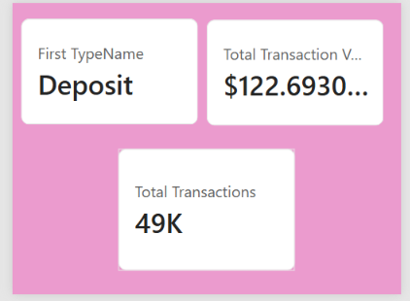

2. Objectives of the Project
- To present financial transaction information in a clear and interactive dashboard.
- To monitor key indicators such as total customers, active accounts, active loans and total transaction value.
- To compare transaction types such as deposits, transfers, withdrawals and payments.
- To examine the distribution of accounts across account types.
- To summarise loan status and identify the number of active, paid-off and overdue loans.
- To use Power BI visualisations, filters and DAX measures to support data-driven analysis.

3. Dataset Description
The report uses a relational financial dataset containing information about transactions, customers, accounts, branches and loans. The Fields pane in the Power BI model shows tables such as Account Statuses, Account Types, Accounts, Addresses, Branches, Customer Types, Customers, Loan Statuses, Loans, Transaction Types and Transactions.
Table / Data Area | Typical Information | Purpose in the Dashboard
Transactions | Transaction type, date/month, transaction value | Trend over time and transaction-type comparison
Accounts | Account identifier and account type/status | Account distribution and active account count
Customers | Customer identifiers and customer categories | Customer KPI and customer-level analysis
Loans | Loan details and loan status | Active, paid-off and overdue loan analysis
Lookup tables | Account types, transaction types, loan statuses, branches | Labels, categories and relationships for filtering
The screenshot indicates approximately 48,510 transactions in the summary table, 1,072 total customers, 1,297 active accounts, 213 active loans and a total transaction value of about $122.69 million. These values are reproduced from the displayed report and should be checked against the final dataset before submission.

4. Data Preparation and Modelling
Before creating visuals, the data should be checked for missing values, duplicate records, inconsistent labels and incorrect data types. Date fields should be converted to Date format, transaction values to numeric/currency format, and category fields to text. Lookup tables should be connected to the relevant fact tables using valid keys.
- Check and remove duplicate records only when they are confirmed to be duplicates.
- Review blank customer, account, transaction and loan identifiers.
- Set suitable data types for dates, amounts, IDs and category fields.
- Create or use a calendar table if time-based analysis is required.
- Validate relationships between Transactions, Accounts, Customers and Loans.
- Format currency and large numbers consistently across cards and tables.

5. KPI Cards and Key Values
KPI cards provide a quick summary of the most important metrics. In this dashboard, the cards highlight customer count, active accounts, active loans and total transaction value. A separate transaction summary visual reports the transaction count and value by transaction type.
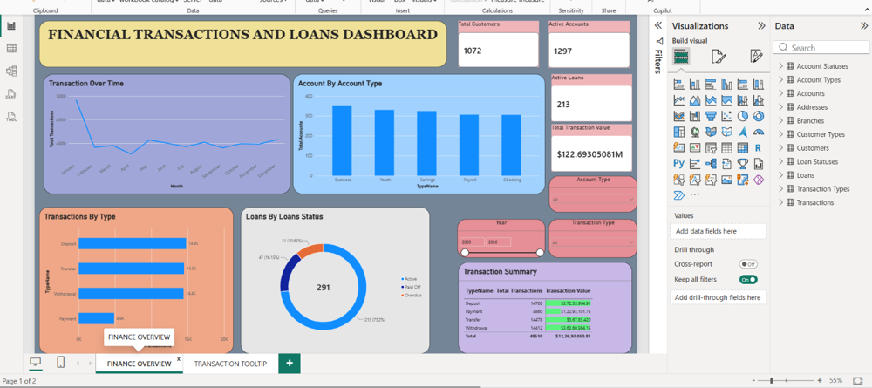

KPI | Displayed Value | Meaning
Total Customers | 1,072 | Number of customers represented in the report
Active Accounts | 1,297 | Accounts currently classified as active
Active Loans | 213 | Loans currently classified as active
Total Transaction Value | $122.69M approx. | Combined value of transactions in the current filter context
Total Transactions | 48.5K approx. | Number of transaction records included in the summary

6. DAX Measures
DAX (Data Analysis Expressions) is the formula language used in Power BI to create measures and calculated columns. The following examples are templates based on the table names visible in the supplied report. Exact column names may differ in the source model, so they should be adjusted to match the actual fields.
Total Transactions
Total Transactions = COUNTROWS('Transactions')
Total Transaction Value
Total Transaction Value = SUM('Transactions'[TransactionValue])
Total Customers
Total Customers = DISTINCTCOUNT('Customers'[CustomerID])
Active Accounts
Active Accounts = CALCULATE(DISTINCTCOUNT('Accounts'[AccountID]), 'Account Statuses'[StatusName] = "Active")
Active Loans
Active Loans = CALCULATE(COUNTROWS('Loans'), 'Loan Statuses'[StatusName] = "Active")
Note: If status names are stored directly in the Accounts or Loans table, or if the model uses different key/column names, revise the formulas accordingly. The active-status measures also depend on correct relationships between the status lookup tables and the fact tables.

7. Dashboard Components and Visuals
Transaction Over Time — line chart: Shows monthly transaction volume and makes it easier to compare changes across the year.
Account by Account Type — column chart: Compares account counts across Business, Youth, Savings, Payroll and Checking categories.
Transactions by Type — horizontal bar chart: Compares Deposit, Transfer, Withdrawal and Payment volumes.
Loans by Loan Status — doughnut chart: Displays the distribution of loans across Active, Paid Off and Overdue statuses.
KPI cards: Summarise total customers, active accounts, active loans and transaction value.
Slicers: Allow the user to filter the report by account type, year and transaction type.
Transaction Summary table: Shows transaction counts and values by transaction type and includes a total row.

8. Dashboard Insights
- The summary table shows approximately 48,510 transactions across four main transaction types.
- Deposits, transfers and withdrawals each account for roughly 14,000–14,800 records, while payments are lower at about 4,860 records.
- Business accounts appear to be the largest account category, followed by Youth and Savings; Payroll and Checking are slightly lower.
- The loan-status visual shows 291 loans in total in the chart, with 213 active, 47 paid off and 31 overdue. These counts should be reconciled with the KPI card and loan-status filters.
- The transaction trend chart starts at a high level in January, falls in February, and then fluctuates around a relatively stable range for the remaining months.
- The report includes Year and Transaction Type slicers, so displayed values can change when filters are applied.

9. Limitations and Recommendations
The report is based on the dashboard screenshot rather than the underlying data file. Therefore, some field names and formulas in this document are examples, and all final values should be verified in Power BI. In particular, the total transaction value should use a clearly defined currency and consistent formatting. The dashboard also displays 213 active loans on a KPI card but 291 loans in the doughnut chart; this may be correct if one is an active-only measure and the other is the total across statuses.
- Add a date range or month slicer for more focused trend analysis.
- Use tooltips to show transaction counts, values and percentages when a user hovers over a chart.
- Check that every KPI responds correctly to report filters.
- Add clear currency labels and consistent decimal/number formatting.
- Validate loan status totals and explain the difference between active loans and total loans.

10. Conclusion
The Financial Transactions and Loans Dashboard demonstrates how Power BI can convert financial data into an interactive and easy-to-understand report. KPI cards provide a quick overview, charts reveal transaction and account patterns, and loan-status visuals support monitoring of lending activity. DAX measures and slicers make the report more flexible and useful for analysis. After validating the data model, formulas and currency settings, the dashboard can support clearer reporting and better-informed financial decisions.

